**JMeter Docker**

**Installation**



**Performance Testing Framework on Docker**

This framework could be used both for backend load testing with Apache JMeter and frontend load test with sitespeed.io + webpage test private instance.

**Custom Grafana dashboards features:**

* **view** application/server-side metrics in real time while test is running
* **analyze** errors cause with detailed traces for failed requests
* **compare** different test runs in scripted dashboard

#### Dashboard demo

[](https://github.com/serputko/performance-testing-framework/blob/master/docs/img/grafana_dashboard_demo.gif)

#### Tests comparison

[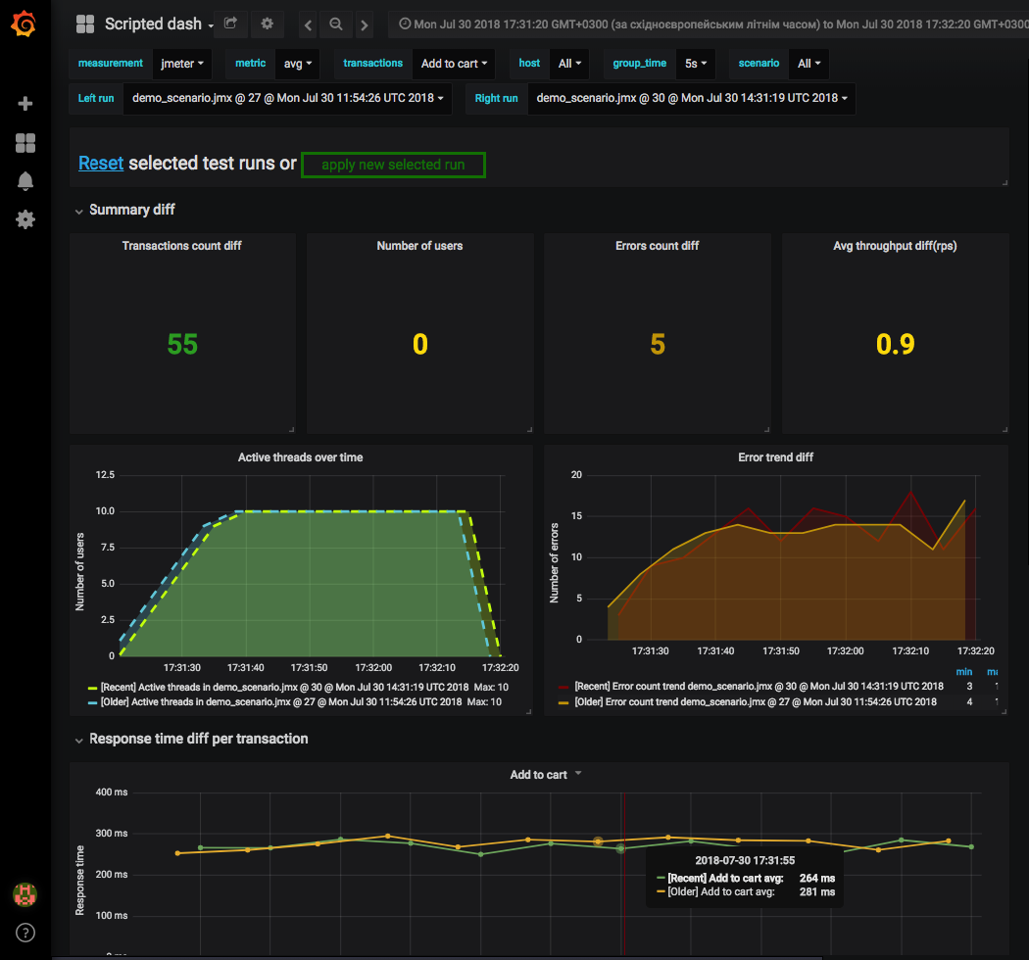](https://github.com/serputko/performance-testing-framework/blob/master/docs/img/grafana_compare_tests_demo.png)

## **Getting Started**

Framework consists of next services:

* **Grafana**: data visualization & monitoring
* **Influxdb**: time series DB platform for metrics & events (Time Series Data)
* **Telegraf**: server agent for collecting & reporting metrics
* **Sitespeed.io**: set of tools for frontend load testing
* **Graphite**: time series DB platform for metrics
* **Jenkins**: continuous integration server for tests execution
* **Portainer**: service for managing docker environment
* **Webpagetest**: private instance of webpagetest server for frontend tests execution
* **Apache Jmeter**: tool for backend load testing

## **Framework architecture:**

[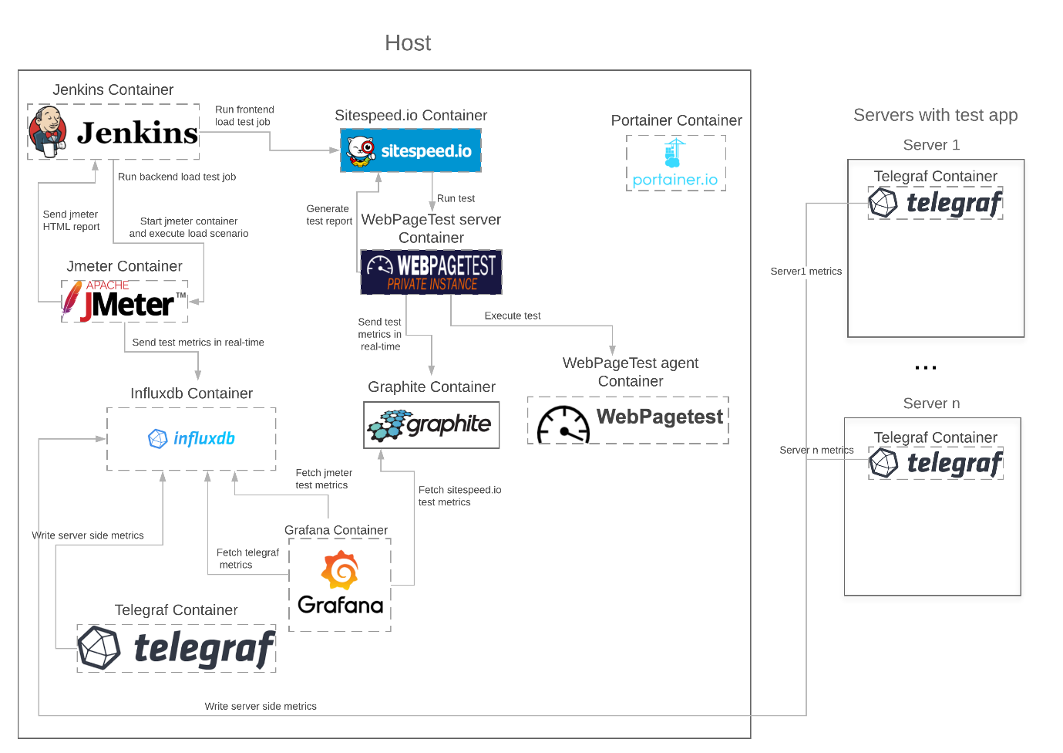](https://github.com/serputko/performance-testing-framework/blob/master/docs/img/Framework%20structure.png)

## **Prerequisites**

1. Install Git Desktop
2. Install Git Bash
3. Install Docker Desktop
4. Download kubectl and set the path in Env variables

## **Installation Process**

1. Clone this repository git clone https://github.com/serputko/performance-testing-framework.git
2. open performance-testing-framework dir

**For Backend testing:**

1. (optional) if you want to update existing services

docker-compose pull

docker-compose build

docker-compose down

1. docker-compose up -d

**For Frontend + Backend testing**

1. (optional) if you want to update existing services

docker-compose -f docker-compose-with-frontend.yml pull

docker-compose -f docker-compose-with-frontend.yml build

docker-compose -f docker-compose-with-frontend.yml down

1. docker-compose -f docker-compose-with-frontend.yml up -d

All containers should be up and running

### Services endpoints

* **jenkins** localhost:8181
* **grafana** localhost:8857
* **portainer** localhost:9000
* **webpagetest server** localhost:80
* **influxdb** localhost:8653

## **Jenkins**

Login to Jenkins with admin/admin(could be changed in docker-compose file) [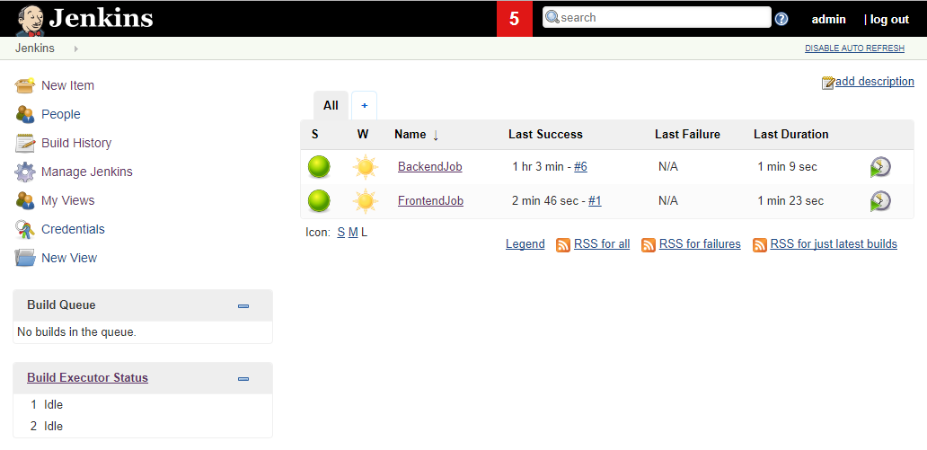](https://github.com/serputko/performance-testing-framework/blob/master/docs/img/jenkins_dashboard.png) By default jenkins consists of 2 jobs:

* **BackendJob**: run Jmeter scenarios
* **FrontendJob**: run tests with sitespeed.io and webpagetest private instance

## **Running demo JMeter scenario with Backend Job**

[](https://github.com/serputko/performance-testing-framework/blob/master/docs/img/jenkins_backendjob_start_test.gif)

To run jmeter demo script: **Open BackendJob -> Build with Parameters -> Set build parameters -> Select scenario -> Build**

This job will start jmeter docker container and execute demo_scenario.jmx jmeter scenario [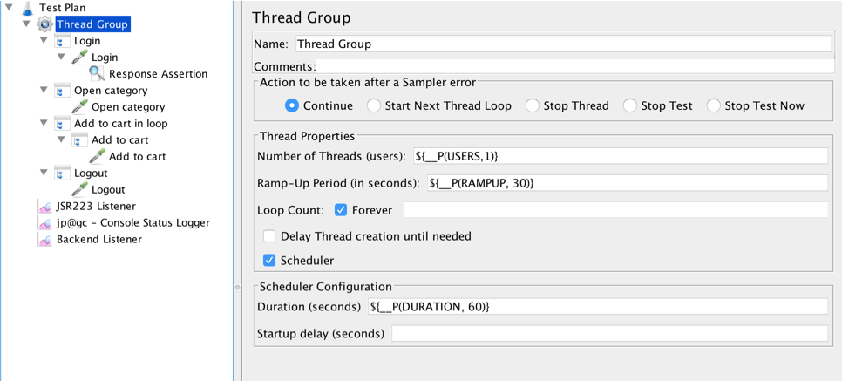](https://github.com/serputko/performance-testing-framework/blob/master/docs/img/jmeter_demo_scenario.png)

To open demo scenario in local instance of JMeter please install Plugin Manager <https://jmeter-plugins.org/wiki/PluginsManager/>. It will automatically install all required plugins.

## Making your JMeter script compatible with framework

Create JMeter test scenario

Modify your JMeter scenario to work with framework, add:

* **JSR223 Listener from demo scenario** Contains groovy script that:
  + Generates detailed trace about request/response info for failed samplers
  + Posts generated trace to JMeter log(could be viewed in Jenkins job)
  + Set trace to sampler response message. If failed samplers are part of Transaction Controller (generate parent sample enabled) all traces will be set to Transaction Controller response message
* **Backend Listener from demo scenario** Sends samplers data to influx dB database. Fields:
  + **application** - groovy script set field value in next format:
* .jmx file title @ Jenkins build number @ test start time (f.e. demo_scenario.jmx @ 18 @ Sat Jul 28 09:44:26 UTC 2018)
  + **test Title** - groovy script generates parameterized title like:
* Jenkins build #18 http://127.0.0.1:8181/job/BackendJob/18/ with demo_scenario.jmx scenario with 10 users, 180 sec ramp up and 600 sec duration was started
  + **event Tags** - info from test Title field in tag format

Data from these fields will be displayed in Grafana dashboard annotations- Green/Red vertical lines that stands for test Start/End. [](https://github.com/serputko/performance-testing-framework/blob/master/docs/img/grafana_annotations_demo.gif)

* (optional) **jp@gc - Console Status Logger** sends minimalistic stats to jenkins console output about test execution:
* #43 Threads: 3/10 Samples: 16 Latency: 23 Resp.Time: 197 Errors: 2
* #44 Threads: 3/10 Samples: 16 Latency: 32 Resp.Time: 203 Errors: 1

## **Grafana**

Start demo_scenario.jmx test with Jenkins Backend job

Real time results should be available in Grafana Open 'Load test monitoring' dashboard. Dashboard contains visualizations based on data from influx dB.

### Available metrics

Dashboard has multiple rows with different metrics[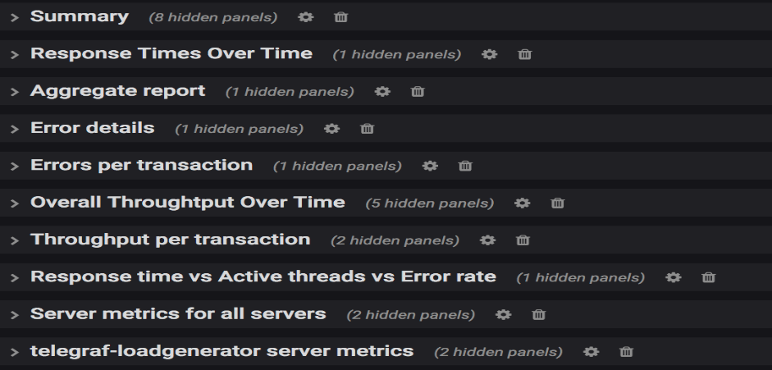](https://github.com/serputko/performance-testing-framework/blob/master/docs/img/grafana_dashboard_available_stats.png)

### Timerange

[](https://github.com/serputko/performance-testing-framework/blob/master/docs/img/grafana_set_time_range.gif)All values in visualizations are calculated according to selected time range. Default time range is last 15 min with 10 sec refresh.

### Templating

Graphs and series on dashboard are displayed dynamically according to variables selected

* **group_time** - aggregation time
* **metric** - which series to show on Response Times Over Time graph(default All)
* **scenario** - results of which scenario to display
* **transactions** - which transactions to show on Response Times Over Time row(default All). transaction variable depends on scenario variable
* **server_measurements** - which server side metrics to show
* **host** - for which servers show monitoring

### Failed requests details

If JSR223 listener was added to scenario than detailed traces for failed requests can be viewed in 'Error details' table. Example of failed request:

Number of samples in transaction : 1, number of failing samples : 1

Login; Response message: Unauthorized;

Status code: 401;

Number of failed assertions: 1

Sample Failed: Login

Started at: Mon Jul 30 11:54:59 UTC 2018

Finished at: Mon Jul 30 11:54:59 UTC 2018

Request:

{

"code": "1234567"

}

REQUEST DATA

URL: http://demo-server.com/login

Request headers:

Content-Type: application/json

Response:

Unauthorized

Response code:401

Response data:

{

"Error message": "Incorrect password or confirmation code entered. Please try again."

}

Assertion results:

Number of failed assertions: 1

Response Assertion Failed;

Failure Message: Test failed: text expected to contain /success/;

### Test runs comparison

Tests comparison is done using scripted js dashboard. It could be accessed at <http://127.0.0.1:8857/dashboard/script/compare_tests.js>

[](https://github.com/serputko/performance-testing-framework/blob/master/docs/img/grafana_compare_tests_demo.gif)

## **FrontendJob**

To run frontend test: **Open FrontendJob -> Build with Parameters -> Set build parameters -> Build** [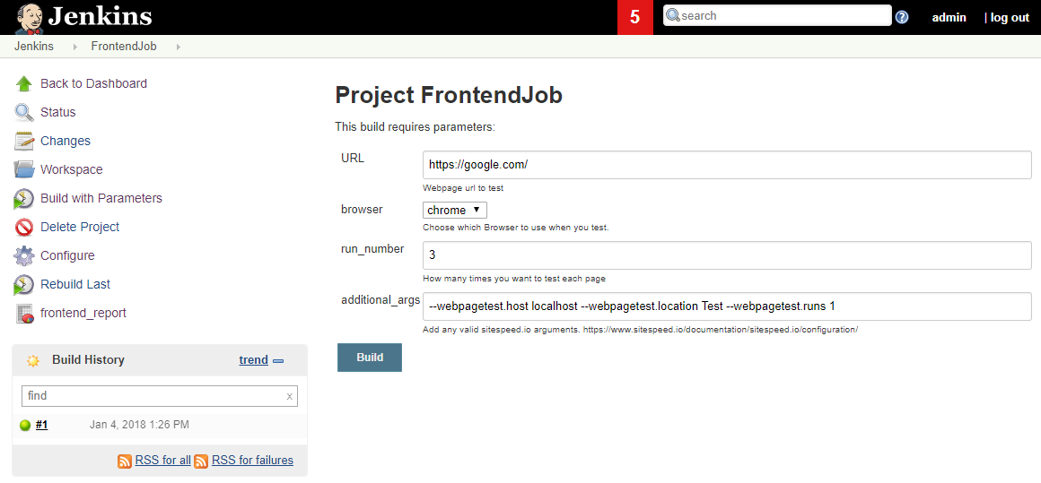](https://github.com/serputko/performance-testing-framework/blob/master/docs/img/jenkins_frontendjob_run.png)

This job will start sitespeed.io docker container and run test with parameters using WebPageTest private instance

Frontend test deliverables:

* **sitespeed.io HTML report**

[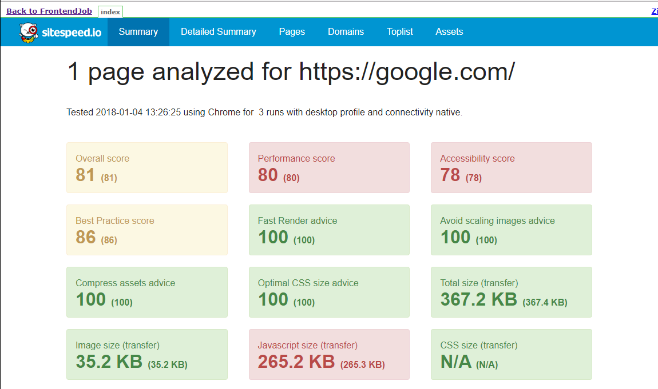](https://github.com/serputko/performance-testing-framework/blob/master/docs/img/jenkins_frontendjob_sitespeed_html_report.png)

[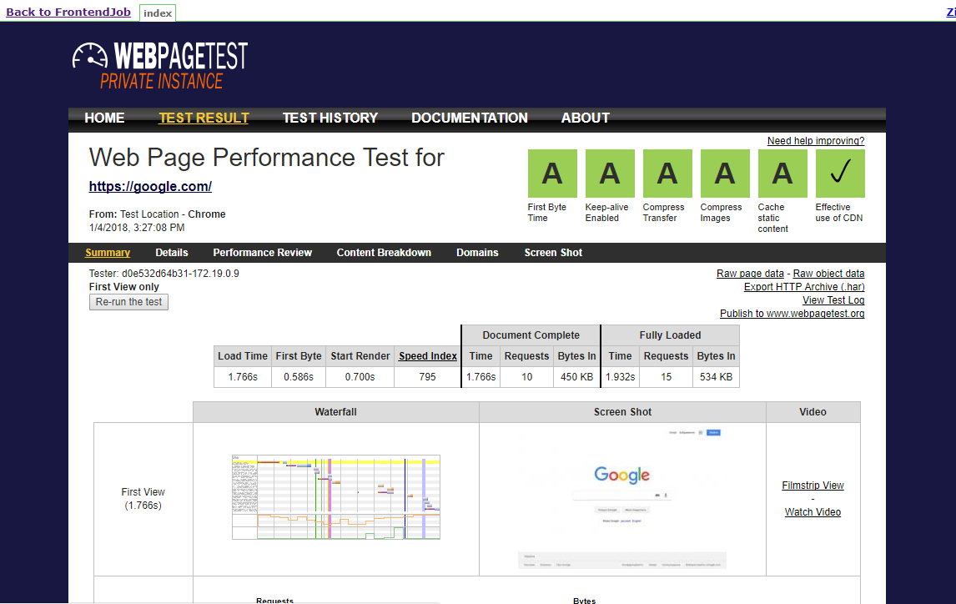](https://github.com/serputko/performance-testing-framework/blob/master/docs/img/jenkins_frontendjob_webpagetest_html_report.png)**Web Page Test HTML Report**

**Refer:** <https://github.com/serputko/performance-testing-framework>